**Project Design Phase-II**

**Technology Stack (Architecture & Stack)**

|  |  |
| --- | --- |
| Date | 15October 2022 |
| Team ID | PNT2022TMID02241 |
| Project Name | Estimate the crop yield using data analytics |
| Maximum Marks | 4 Marks |

**Technical Architecture:**

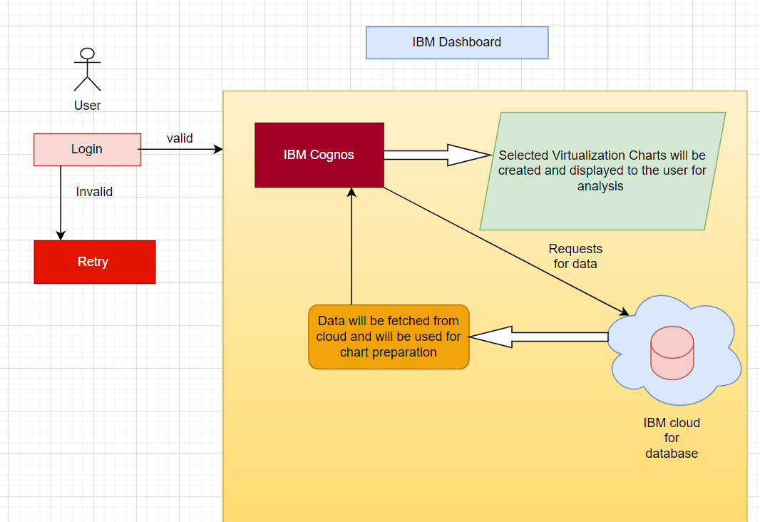

**Table-1 : Components & Technologies:**

|  |  |  |  |
| --- | --- | --- | --- |
| **S.No** | **Component** | **Description** | **Technology** |
|  | User Interface | How user interacts with application e.g.  Web UI, Mobile App, Chatbot etc. | HTML, CSS, JavaScript |
|  | Application Logic-1 | Logic for a process in the application | Java / Python |
|  | Database | Data Type, Configurations etc. | MySQL, NoSQL |
|  | Cloud Database | Database Service on Cloud | IBM Cloudant |
|  | File Storage | File storage requirements | IBM Block Storage or Other Storage Service or Local Filesystem |
|  | External API-1 | Deliver a rich set of accurate and precise weather data | IBM Weather API |
|  | External API-2 | soil data helps to manage and monitor the soil quality for better crop yields, operational efficiency, and increased profits | Soil API |
|  | Machine Learning Model | Linear regression analysis is used to predict the value of a variable based on the value of another variable | Linear regression |
|  | Infrastructure (Server / Cloud) | Application Deployment on Local System / Cloud  Local Server Configuration:  Cloud Server Configuration : | Local, Cloud Foundry, Kubernetes, etc. |

**Table-2: Application Characteristics:**

| **S.No** | **Characteristics** | **Description** | **Technology** |
| --- | --- | --- | --- |
|  | Open-Source Frameworks | Bootstrap is the easy understanding open-source framework available to work. | Bootstrap |
|  | Security Implementations | Provides security to the system by giving access to only the authorised users. | User Authentication |
|  | Scalable Architecture | A 3-tier architecture is used to retrieve, modify and store the data into cloud and cognos. | IBM Cloud and IBM Cognos |
|  | Availability | It integrates reporting, modeling, analysis, dashboards, stories, and event management and also available for all the users | Cognos Analytics |
|  | Performance | Designing the dashboard to analyse a wide range of crop yield | IBM Instance |

**References:**

[**https://c4model.com/**](https://c4model.com/)

[**https://developer.ibm.com/patterns/online-order-processing-system-during-pandemic/**](https://developer.ibm.com/patterns/online-order-processing-system-during-pandemic/)

[**https://www.ibm.com/cloud/architecture**](https://www.ibm.com/cloud/architecture)

[**https://aws.amazon.com/architecture**](https://aws.amazon.com/architecture)

[**https://medium.com/the-internal-startup/how-to-draw-useful-technical-architecture-diagrams-2d20c9fda90d**](https://medium.com/the-internal-startup/how-to-draw-useful-technical-architecture-diagrams-2d20c9fda90d)